



Université Sidi Mohamed Ben Abdallah

Faculté des Sciences Dhar Mahraz – Fès

**Rapport de stage de Fin d’Études**

Présenté pour l’obtention du

**Diplôme de Master Big Data Analytics and Smart Systems**

Intitulé :

**Modeling Driving Maneuvers Using Autoregressive Input-Output HMM**

**Sous la direction de :**

**Ismail Berrada**

**Réalisé par :**

**Ikram EL KARFI**

**Présenté le   20 juin 2017 Devant le Jury composé de :**

**Pr. Ahmed DRISSI AL MALIANI**

**Pr. Ismail BERRADA**

**Pr. Mohammed CHAHHOU**

**Pr. Mohammed EL KAMILI**



**Année Universitaire : 2016 / 2017**

***Modeling Driving Maneuvers Using Autoregressive Input-Output HMM***

Ikram El Karfi and Ismail Berrada

University of Sidi Mohammed Ben Abdellah

Fez, Morocco

ikram.el.karfi@usmba.ac.ma, ismail.berrada@univ-lr.fr

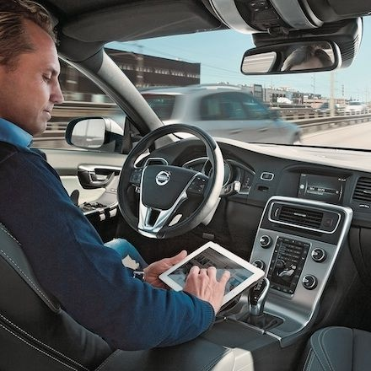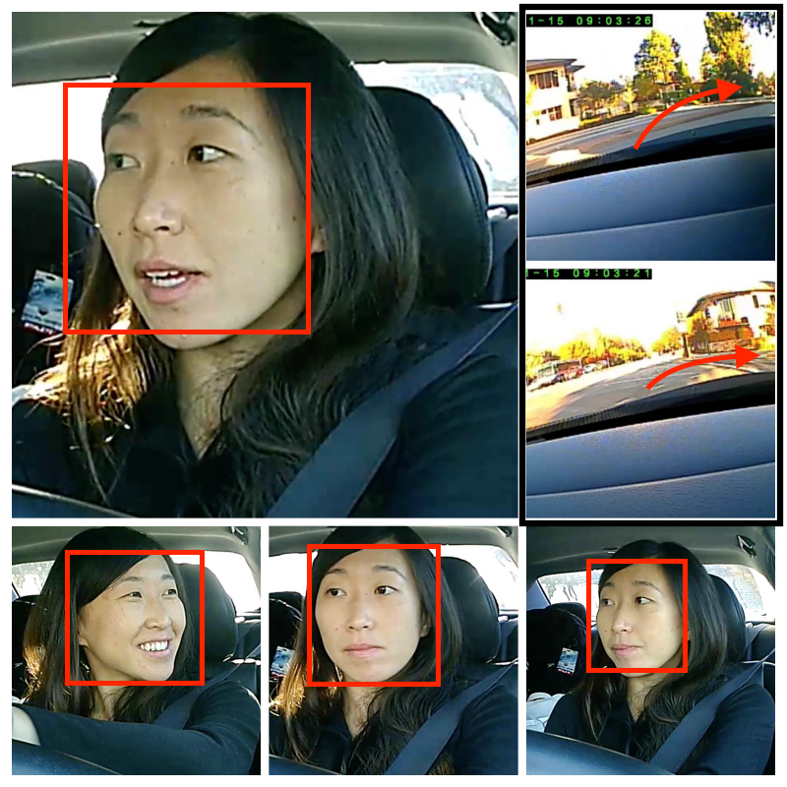

*Abstract*—According to the World Health Organization, every year the lives of approximately 1.25 million people are cut short as a result of a road traffic crash, and without sustained action, road traffic crashes are predicted to become the seventh leading cause of death by 2030. If we could at least prevent dangerous maneuvers that a driver can make we can reduce traffic fatalities.

In this paper we introduce an autoregressive hidden Markov model (HMM) and demonstrates its application to anticipate maneuvers several seconds before they occur. The results of this model enable the Advanced Driver Assistance System (ADAS) to alert the driver to avoid dangerous maneuvers.

Keywords—hidden Markov model ; Autoregressive Input-Output HMM; maneuver anticipation.

# Introduction

|  |
| --- |
| The discovery of automobiles has been one of the most significant of the various innovations of the previous centuries and it cannot be denied that today automobiles and vehicles have a significant role to play in society. |

Nowadays we're in the midst of a significant transformation in how we get around. For over a century, mobility has meant buying a car, but over the course of the next century, it might mean something else: buying a car, sharing a car, summoning a self-driving car with a smartphone.

**Autonomous vehicles (**Fig 1) (also known as self-driving cars or robotic cars) are motor vehicles that operate without a human driver, which reduces the cost of transportation and improves convenience and (in most cases) safety.

**Connected cars**(Fig 2) are those that have access to the Internet and a variety of sensors, and that are thus able to send and receive signals, sense the physical environment around them, and interact with other vehicles or entities.

1. Autonomous vehicle

A formal classification system for automated cars has been proposed by the National Highway Traffic Safety Administration:

**Level 0:** Driver has complete control of vehicle at all times.

**Level 1:** Some vehicle controls are automated, e.g. automatic braking.

**Level 2:** Two or more controls can be automated at the same time, e.g. cruise control and lane keeping.

**Level 3:** The driver can cede control in certain circumstances.

**Level 4:** Driver not expected to play any part in the driving process at all.

It comes as no surprise that internet-connected cars and devices are surging in popularity, here is some of the real-world tangible benefits of connected car technology:

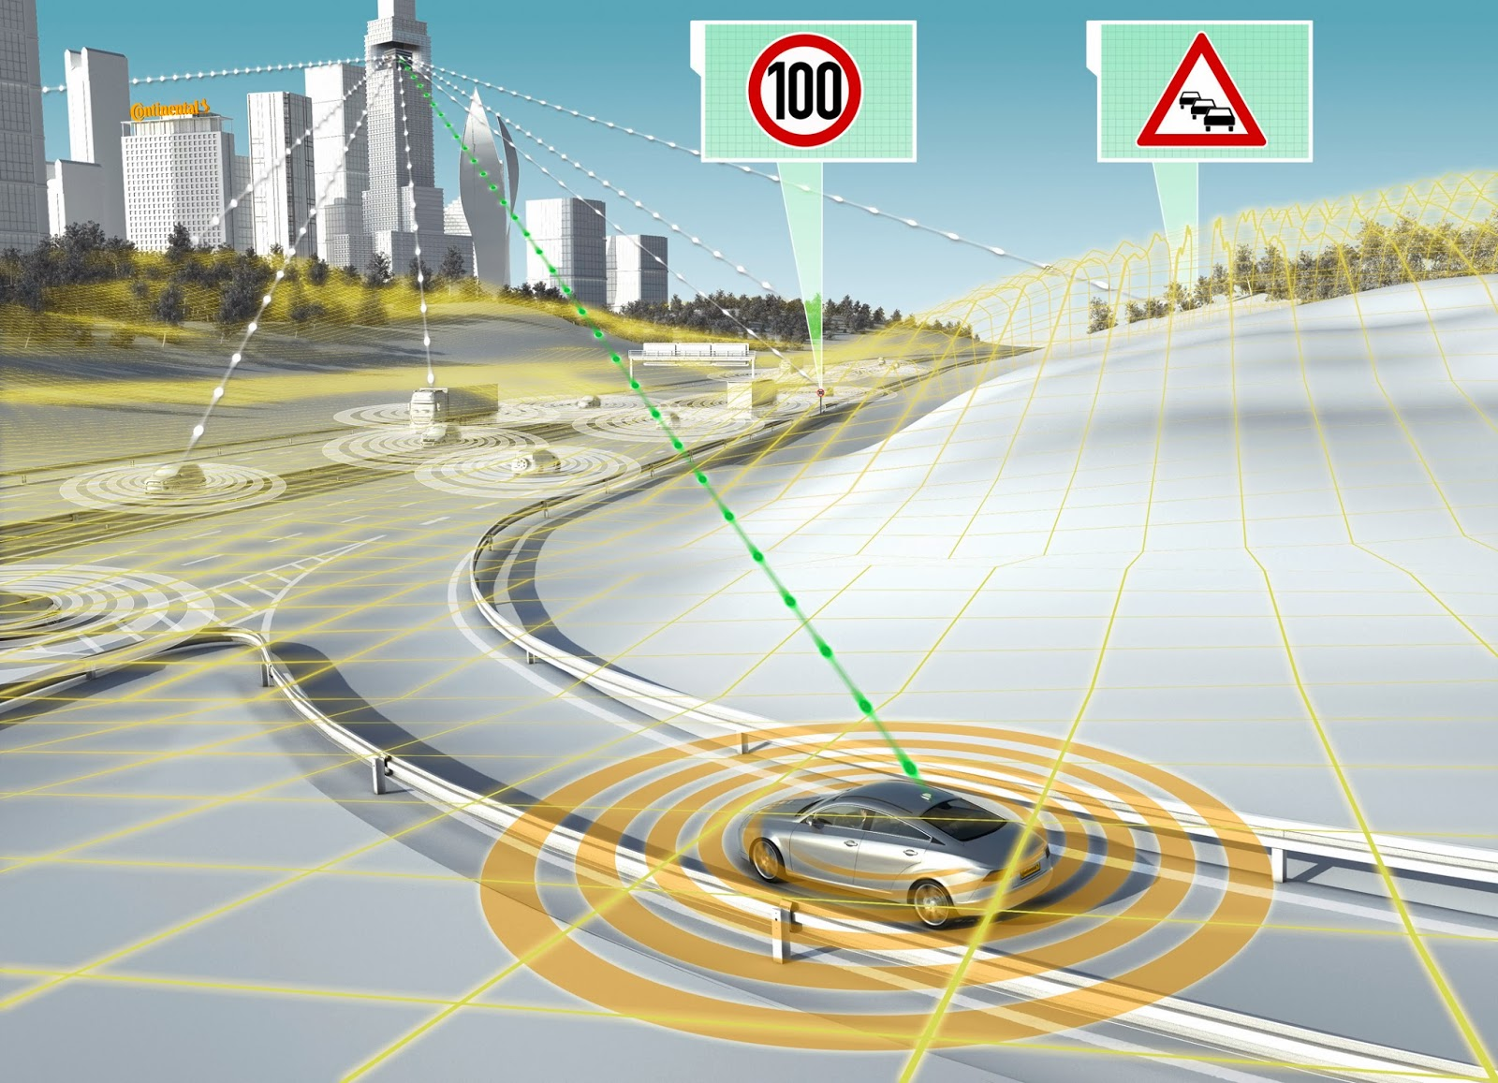

1. The Future of the Connected Car

**Safety:** Every year 1.25 million driving deaths in total around the world. An internet-connected vehicle could identify hazards in advance and take corrective steps. Imagine a car that can predict traffic at a stand-still around a sharp corner, slowing down in advance.

**Repairs:** Vehicles are huge investment. Internet-connected vehicles could allow for garages to offer remote diagnosis and ongoing vehicle health monitoring.

**Traffic Congestion:**As population centers continue to grow, traffic congestion has become an issue for many cities. It is particularly problematic in cities with poor infrastructure. Connected cars could help to alleviate traffic congestion by choosing alternate routes. They could also work with municipalities to balance roadway usage.

**Save time:**There is no doubt that having access to real-time traffic information saves us time. We already experience every day with GPS apps. However, with autonomous driving coming in the not-so-distant future, real-time connectivity will improve decision-making.

**Entertainment:** The internet is home to limitless entertainment, some of which can be safely enjoyed while driving. Music, radio, news, and podcasts are all already a regular part of our driving entertainment. When autonomous vehicles are more common, that list may include movies, television, or video games.

There are many startups that are vying to find their foothold in the connected car market, here is some of the connected car startups out there:

There are many startups that are vying to find their foothold in the connected car market, here is some of the connected car startups out there:

## **Airbiquity**

## **Otonomo**

## **Mojio**

## **Brain4Cars**

* **Automile**

Automakers throughout the global auto industry are working hard to make the vision of the connected car and autonomous vehicles a reality, experimenting, testing, and building the technology that will further connect cars to the world around them, and developing prototypes of cars that can already drive themselves.

GM, for example, has been reducing outsourcing contracts and instead has hired more than 8,000 software developers, while Bosch is looking to employ 14,000 software engineers in 2016 alone to develop features for the connected vehicle as part of its push into the Internet of Things.

"The car is a platform, and we're excited by the opportunities that are emerging as we provide makers and developers with access to real-time vehicle data," said TJ Giuli, Silicon Valley research lab leader for Ford.

As contribution in this domain our primary aim is to predict a human driver’s next maneuver several seconds before he or she makes it. This can prevent potential accidents as said before.

As you can see, the future of these cars isn’t a fiction, it’s real. Now more and more often we hear that self driving cars will replace today’s vehicles and it is inevitable. The question is how fast we will adapt to a new reality providing the infrastructure software for this technology. It is self driving cars development that can be our chance - to discover and develop new industry. The future, is not so far and we need to be ready for it.

In the next couple of years there will be even more growth and expansion of applications leveraging vehicle data because of the lower barrier to entry for developers.

# Related works

In this section, we present an overview of several works have studied human activity anticipation:

**Subarna Shakya , Suman Sharma and Abinash Basnet [1]**

In their paper they used for face detection, viola-jones AdaBoost method in addition to skin color based filtering is used and then Viola-Jones algorithm further used to detect people's faces, noses, eyes, mouth, or upper body on detected face.

For that, classifiers, made of multiple cascade simple classifiers, are set which extracts features using train images. Happiness, sadness, fear, disgust, anger, and surprise are considered in identifying facial expressions.

Facial expression identification can be done in various ways as extracting facial movements based on the muscles that produce those movements using a Facial Action Coding System (FACS). An image included of the eyes and mouth is fed as an input to a feed forward back- propagation neural network. Using the ANN classification was done with good accuracy rate.

Principal Component Analysis (PCA) and K-Nearest Neighbor (KNN) was proposed for facial emotion recognition. Accuracy of human behavior prediction is equivalent with that of face emotion detection.

In their model, they had placed camera at minimum two places (entry and exit gate) with certain distance apart that captures video sequences. The video sequences taken from cameras were then converted to frame sequence, which was done at real time, they chose only 2/3 captured photos where faces can be detected clearly to analyze emotion. If emotion is sad/ surprise/ fear/ anger/ disgust, then they are specially treated for further processing and correlation is done for the image of same person at different place to predict his/her behavior so that the chances for criminal activity can be minimized.

On the other hand, they ignored if smiley, happy, and normal face were detected in all images. they have included database of criminal images, so that it will map the person in CCTV to the image in database. Whenever suspicious person was detected, security alert had been given to respective person. In this paper they performed experiment on different images with different background behavior.

**Mohammed Hayyan Alsibai and Sulastri Abdul Manap [3]**

Aims to develop a driver safety assistant system using an in vehicle video camera. It is a real-time recognition system which uses vision sensors to detect passengers and driver fatigue conditions. The system assesses the ability of conducting safe driving and notifies the driver for any dangerous situation. These studies demonstrated that systems inside vehicles can use information collected about the driver, such as emotional states or distraction levels, to predict unsafe driving behavior. We extend the previous work by attempting to use facial expressions in not only detecting mental and emotional states but also in predicting driving accidents few seconds before they occur.

**Zhao et al. [2]**

In their paper they have presented an extensive survey of machine recognition of human faces and a brief review of related psychological studies. They have considered two types of face recognition tasks: one from still images and the other from video. They describe the most important face databases and their associated evaluation methods, including the XM2VTS and BANCA [Bailly- Bailliere et al. 2003] database.

**Karthik Gopalratnam and Diane J. Cook [12]**

In their article, they investigate the potential of constructing a prediction algorithm based on data compression techniques. their Active LeZi prediction algorithm approaches sequential prediction from an information-theoretic standpoint. For any sequence of events that can be modeled as a stochastic process, ALZ uses Markov models to optimally predict the next symbol.

**Kris Kitani et al [13]**

They address the task of inferring the future actions of people from noisy visual input. They denote this task activity forecasting. To achieve accurate activity forecasting, their approach models the effect of the physical environment on the choice of human actions. This is accomplished by the use of state-of-the-art semantic scene understanding combined with ideas from optimal control theory. Their unified model also integrates several other key elements of activity analysis, namely, destination forecasting, sequence smoothing and transfer learning. As proof-of-concept, they focus on the domain of trajectory-based activity analysis from visual input. Experimental results demonstrate that their model accurately predicts distributions over future actions of individuals. they show how the same techniques can improve the results of tracking algorithms by leveraging information about likely goals and trajectories.

**Activity Recognition on Streaming Sensor Data [14]**

In this paper they propose and evaluate a sliding window based approach to perform activity recognition in an on line or streaming fashion; recognizing activities as and when new sensor events are recorded. To account for the fact that different activities can be best characterized by different window lengths of sensor events, they incorporate the time decay and mutual information based weighting of sensor events within a window. Additional contextual information in the form of the previous activity and the activity of the previous window is also appended to the feature describing a sensor window. The experiments conducted to evaluate these techniques on real-world smart home datasets suggests that combining mutual information based weighting of sensor events and adding past contextual information into the feature leads to best performance for streaming activity recognition.

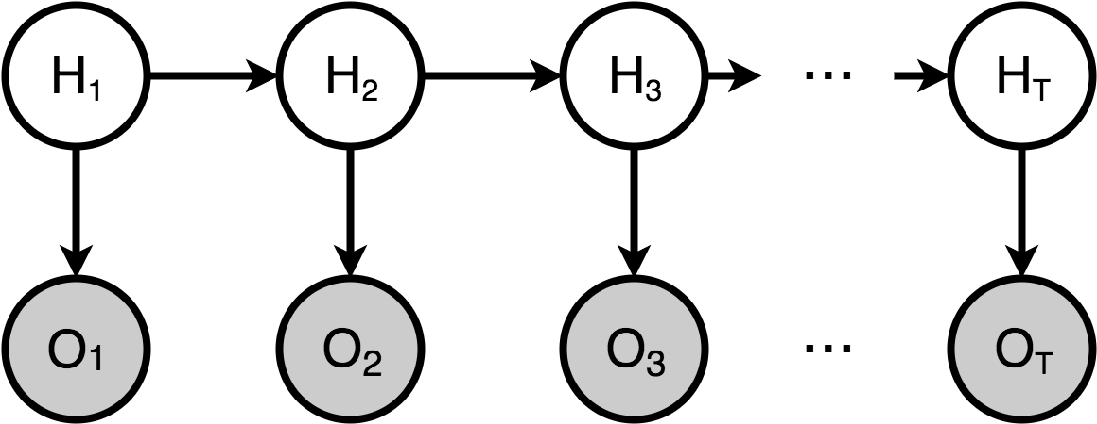

1. HMM graphical model

**Oluwatobi Olabiyi, Eric Martinson, Vijay Chintalapudi, Rui Guo [18]**

In their paper, they have proposed a novel DAP system that integrates both recognition and prediction systems. The proposed prediction system is based on DBRNN, which enables temporal fusion of both past and future context to learn the correlation between sensor data and future driver action. Their prediction system uses deep Bidirectional Recurrent Neural Network (DBRNN) consisting of multiple Long-Short Term Memory (LSTM) units and/or Gated Recurrent Units (GRU) cells that learns to identify as early as possible, the spatial- temporal dependencies in time series data with respect to future driver action.

The high prediction accuracy and prediction horizon performance will enable new driver assistance capabilities to effectively alert drivers before taking dangerous driving actions.

# Hidden State Models

The family of hidden Markov models (HMMs) is a flexible tool for generative probabilistic modeling of sequential data. It is often employed solving for sequential classification tasks. Its applicability has been long proven in areas such as speech recognition [4], natural language processing [5], biological sequence analysis [6], or electrocardiography [7], [8]. For modeling driving maneuvers, we restrict the discussion to a particular type of HMM: the autoregressive HMM. Modeling maneuvers require temporal modeling of the driving context (Fig 3). Discriminative methods, such as the Support Vector Machine and the Relevance Vector Ma- chine [9], which do not model the temporal aspect perform poorly. Therefore, a temporal model such as the Hidden Markov Model (HMM) is better suited.

1. **Autoregressive Input-Output HMM**

An AIO-HMM enhances the HMM architecture by introducing a direct stochastic dependence between observations [10], [11]. It is designed to explicitly model the (possibly long range) correlations in sequential data. We first give a brief description of the model and then explain how it can be applied for modeling driving maneuvers.

Like the HMM, the AIO-HMM models two types of variables: hidden discrete states zt and observations xt. In an HMM, the current observation is independent of all the other observations given the current state. Consequently, there is no explicit constraint on HMM samples to be smooth. The AIO-HMM encourages correlation among observations by adding direct dependencies between them. Samples drawn from an AIO-HMM are thus smoother than samples from an HMM, usually making the former a better generative model in time-series problems.

* 1. **Parameters**

The parameters of a hidden Markov model are of two types, transition probabilities and emission probabilities:

**Transition probabilities:** Control the way the hidden state at time t is chosen given the hidden state at time t-1.

$$P\left(Yt = j | Yt-1= i \right)$$

**Emission probabilities:** The probability of an observation being generated from a state

* 1. **Learning**

The parameter learning task in HMMs is to find, given an output sequence or a set of such sequences, the best set of state transition and emission probabilities. The task is usually to derive the maximum likelihood estimate of the parameters of the HMM given the set of output sequences. No tractable algorithm is known for solving this problem exactly, but a local maximum likelihood can be derived efficiently using the Baum–Welch algorithm or the Baldi–Chauvin algorithm. The Baum–Welch algorithm is a special case of the expectation-maximization algorithm, used to find the maximum likelihood estimate of the parameters of a hidden Markov model given a set of observed feature vectors. Baum–Welch algorithm makes use of the forward-backward algorithm.

**Expectation-maximization (EM) algorithm**

Is an iterative method to find maximum likelihood or maximum a posteriori (MAP) estimates of parameters in statistical models, where the model depends on unobserved latent variables. The EM iteration alternates between performing an expectation (E) step, which creates a function for the expectation of the log-likelihood evaluated using the current estimate for the parameters, and a maximization (M) step, which computes parameters maximizing the expected log-likelihood found on the E step. These parameter-estimates are then used to determine the distribution of the latent variables in the next E step. The basic steps for the algorithm are:

1. Start with initial probability estimates
2. Compute expectations of how often each transition/emission is used
3. Re-estimate the probabilities based on those expectations, and repeat until convergence

**Forward-backward algorithm**

The forward–backward algorithm is an inference algorithm for hidden Markov models which computes the posterior marginals of all hidden state variables given a sequence of observations/emissions $o_{1:t}:=o,…o_{t}$ i.e. it computes, for all hidden state variables $X_{k}ϵ\left\{X_{1},…,X_{t}\right\}$ the distribution $P\left(X_{k} | o_{1:t}\right)$.

This inference task is usually called smoothing. The algorithm makes use of the principle of dynamic programming to compute efficiently the values that are required to obtain the posterior marginal distributions in two passes. The first pass goes forward in time while the second goes backward in time; hence the name forward–backward algorithm.

* 1. **Inference**

The following Algorithm shows the complete inference procedure:

**Algorithm:** Anticipating maneuvers

**input** Driving videos, GPS, Maps and Vehicle Dynamics

**output** Probability of each maneuver

Initialize the face tracker with the driver’s face

**while** driving **do**

Track the driver’s face

Extract features $Z_{1}^{k}$ and $X_{1}^{k}$

Inference $P_{M}$ = $P\left(M | Z_{1}^{k},X_{1}^{k}\right)$

Send the inferred probability of each maneuver to ADAS

**end while**

This approach need a comprehensive knowledge of the driving environment, both inside and outside the car, can be used to make a pretty good guess at the driver’s immediate intentions. For example, drivers usually check the lanes next to them before making lane changes. So monitoring driver head movements helps predict whether the driver intends to change lanes in the next few seconds.

# Model Analysis

1. **Data Set Description**

Data set used in this work was taken from: http://brain4cars.com. This data set gathered from 10 different drivers and with different kinds of driving maneuvers with 1180 miles of natural freeway and city driving collected across two states. Data set consists of natural driving videos with both inside and outside views of the car, its speed, and the global position system (GPS) coordinates. The outside car video captures the view of the road ahead.

1. **Data Pre-processing**

We select and extract features by processing the inside and outside driving contexts. We denote the inside features with Z and the outside features with X.

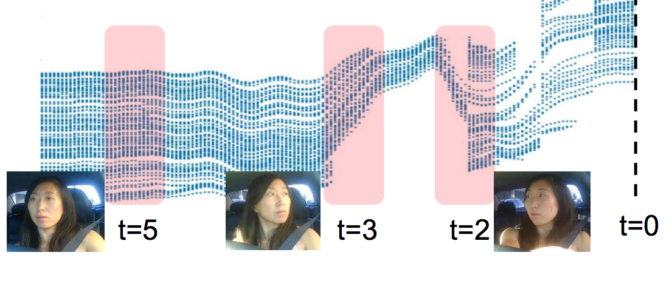

1. Trajectories for the horizontal motion of tracked facial pixels ‘t’ seconds before the maneuver. At t=5 seconds before the maneuver the driver is looking straight, at t=3 looks (left) in the direction of maneuver, and at t=2 looks (right) in opposite direction for the crossing traffic
   1. **Features selection**

**Inside-vehicle Features**

The inside features Z capture the driver’s head movements. Our vision pipeline consists of face detection, tracking, and feature extraction modules. We extract head motion features per-frame. For AIO- HMM, we compute Z by aggregating (extract head motion features per-frame) for every 20 frames. Face detection and tracking. We detect the driver’s face using a trained Viola-Jones face detector [15]. From the detected face, we first extract visually discriminative (facial) points using the Shi-Tomasi corner detector [16] and then track those facial points using the CLM tracker [17]. However, the tracking may accumulate errors over time because of changes in illumination due to the shadows of trees, traffic, etc. We therefore constrain the tracked facial points to follow a projective transformation and remove the incorrectly tracked points using the RANSAC algorithm. While tracking the facial points, we lose some of the tracked points with every new frame. To address this problem, we re-initialize the tracker with new discriminative facial points once the number of tracked points falls below a threshold.

A Constrained Local Model (CLM) is class of methods of locating sets of points (constrained by a statistical shape model) on a target image. The general approach is to:

Sample a region from the image around the current estimate, projecting it into a reference frame

For each point, generate a "response image" giving a cost for having the point at each pixel

Searching for a combination of points which optimizes the total cost, by manipulating the shape model parameters.

For maneuver anticipation the horizontal movement of the face and its angular rotation are particularly important. From the face tracking we obtain face tracks, which are 2D trajectories of the tracked facial points in the image plane. (Fig 4) shows how the horizontal coordinates of the tracked facial points vary with time before a left turn maneuver.

We represent the driver’s face movements and rotations with histogram features.

**Outside-vehicle features**

The outside feature vector X encodes the information about the outside environment such as the road conditions, vehicle dynamics, etc. In order to get this information, we use the road-facing camera together with the vehicle’s GPS coordinates, its speed, and the street maps. More specifically, we obtain two binary features from the road-facing camera indicating whether a lane exists on the left side and on the right side of the vehicle. We also augment the vehicle’s GPS coordinates with the street maps and extract a binary feature indicating if the vehicle is within 15 meters of a road artifact such as intersections, turns, highway exists, etc. We also encode the average, maximum, and minimum speeds of the vehicle over the last 5 seconds as features.

Features selected for driving maneuver anticipation:

*Lane-info* = {lane-no, total-lanes, intersection}

$\left\{\begin{aligned}lane-no :integer \\ total-lanes:integer \\ intersection:boolean\end{aligned}\right.$

Speed = list contains speeds in each video.

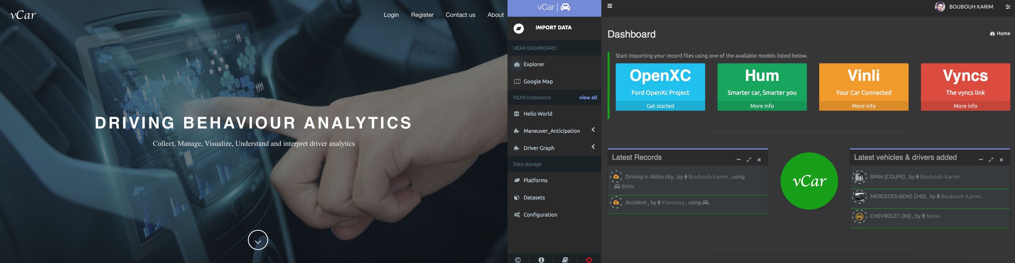

1. The front end and after login interface of vCar.
   1. **Features extraction**

**Inside-vehicle Features**

*Mean-movement-x:* Vector containing the averages movements of horizontal facial pixels.

*Hist-mean-movement-x:* Histogram representing the distribution of the variable mean-movement-x by counting the frequency in each range in [-3.0, -1.0, 1.0, 3.0].

**Outside-vehicle features**

*Speed_features* = {min(speed), max(speed), mean(speed)}

*Lane-features*= {left-action, right-action}

$$\left\{\begin{aligned} Left-action: \left\{\begin{aligned}1 if total-lanes>lane-no \\ else 0\end{aligned}\right. \\ Right-action: : \left\{\begin{aligned}1 if lane-no>1 \\ else 0\end{aligned}\right.\end{aligned}\right.$$

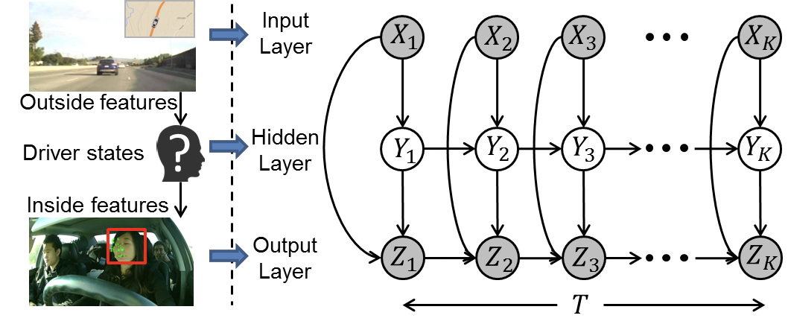

1. AIO-HMM. T represents time
2. **Model description**

Our model has three layers (Fig 6):

* Input (top): this layer represents outside vehicle features X;
* Hidden (middle): this layer represents driver’s latent states Y;
* Out- put (bottom): this layer represents inside vehicle features Z. This layer also captures temporal dependencies of inside vehicle features.

Given $T$ seconds long driving context $C$ before the maneuver $M$, we learn a generative model for the context $P\left(C | M\right).$ The driving context C consists of the outside driving context and the inside driving context. the outside driving context and the inside driving context. The outside and inside contexts are temporal sequences represented by the outside features $X_{1}^{k}= \left\{X_{1},…,X_{k}\right\}$ and the inside features $Z_{1}^{k}= \left\{Z_{1},…,Z_{k}\right\}$. The corresponding sequence of the driver’s latent states is $Y_{1}^{k}= \left\{Y_{1},…,Y_{k}\right\}$.

$$P\left(C/M\right)= \sum{P(Z_{1}^{k},X_{1}^{k}},Y_{1}^{k}/M)$$

X and Z are vectors and Y is a discrete state.

Our learning algorithm trains separate AIO-HMM models for each maneuver. The goal during inference is to determine which model best explains the past T seconds of the driving context not seen during training. We evaluate the likelihood of the inside and outside feature sequences $Z_{1}^{k}$ and $X_{1}^{k}$ for each maneuver, and anticipate the probability $P_{M}$ of each maneuver $M$ as follows:

$$P_{M}= P\left(M | Z_{1}^{k},X_{1}^{k}\right)$$

The training data D = $\{(X_{1,n}^{Kn}, Z_{1,n}^{Kn})|n = 1, .., N \}$ consists of N instances of a maneuver M . The goal is to maximize the data log-likelihood.

Directly optimizing is challenging because parameters Y representing the driver’s states are latent. We therefore use the iterative EM procedure to learn the model parameters. In EM, instead of directly maximizing we maximize its simpler lower bound. We estimate the lower bound in the E-step and then maximize that estimate in the M-step. These two steps are repeated iteratively.

# Implementation

In this section, we describe experimental results for detecting driving maneuvers.

1. **vCar Platform and Plugin Architecture**

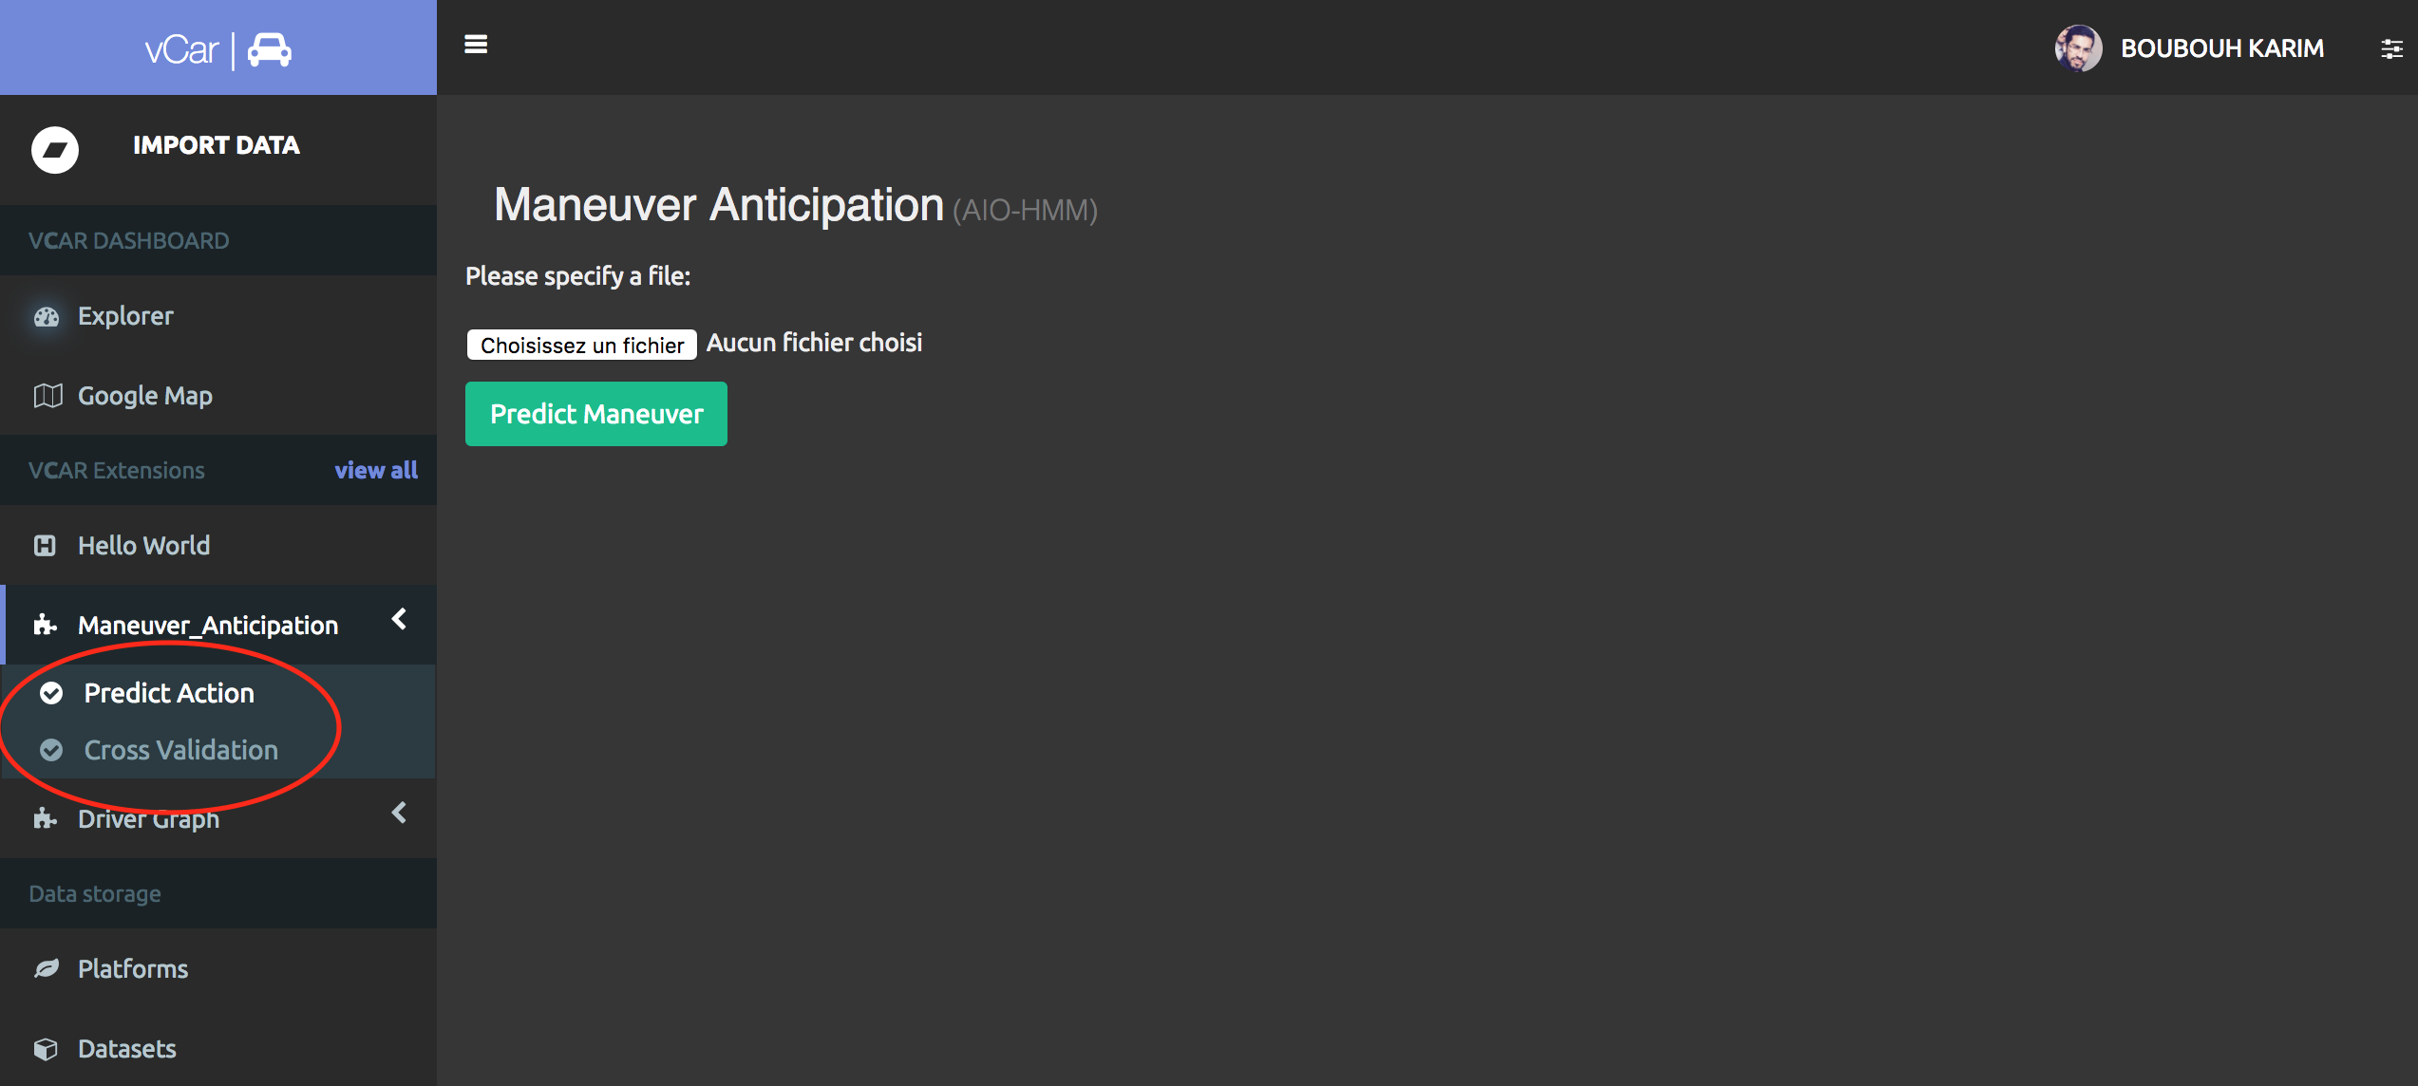vCar is a platform (Fig 5) dedicated for analyzing and visualizing the behavior of the car and the driver, while providing a bunch of third-party services that makes life easier for both analysts and drivers. This platform is a web site developed with a long-term vision, ensuring the possibility of being extensible with new features developed by students or the community. Also this platform will be a very good example for students to motivate them to invest more time in the field of intelligent cars.

1. 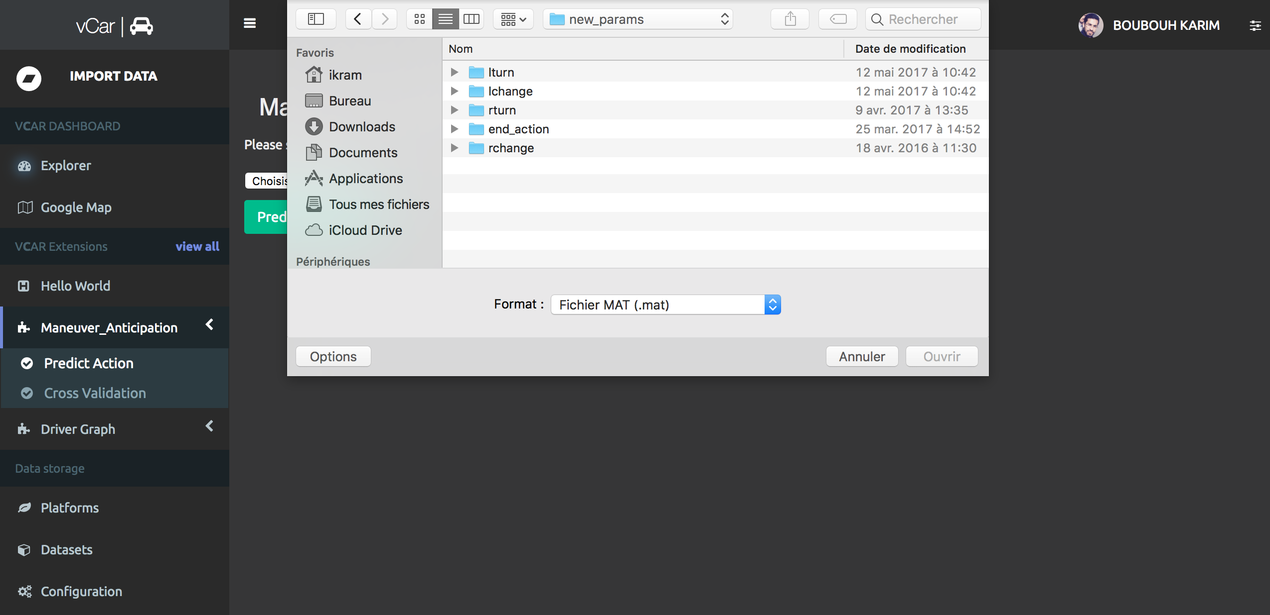Two types of prediction .
2. 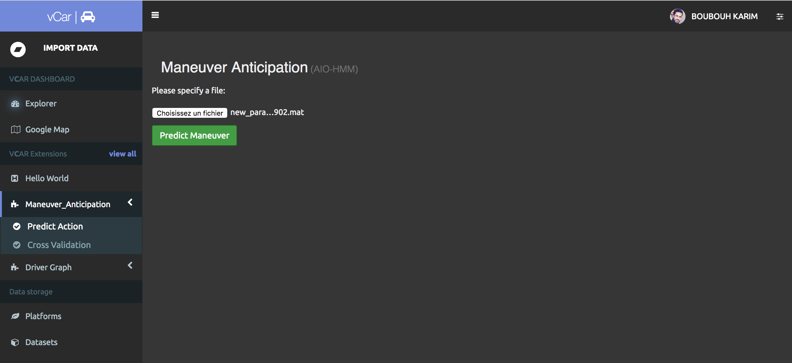Uploading a file (.mat) to predict his maneuver
3. After uploading the file

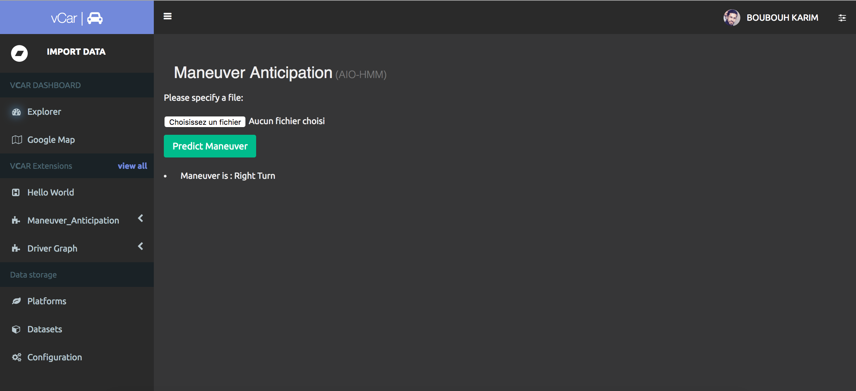

1. The predected maneuver appears

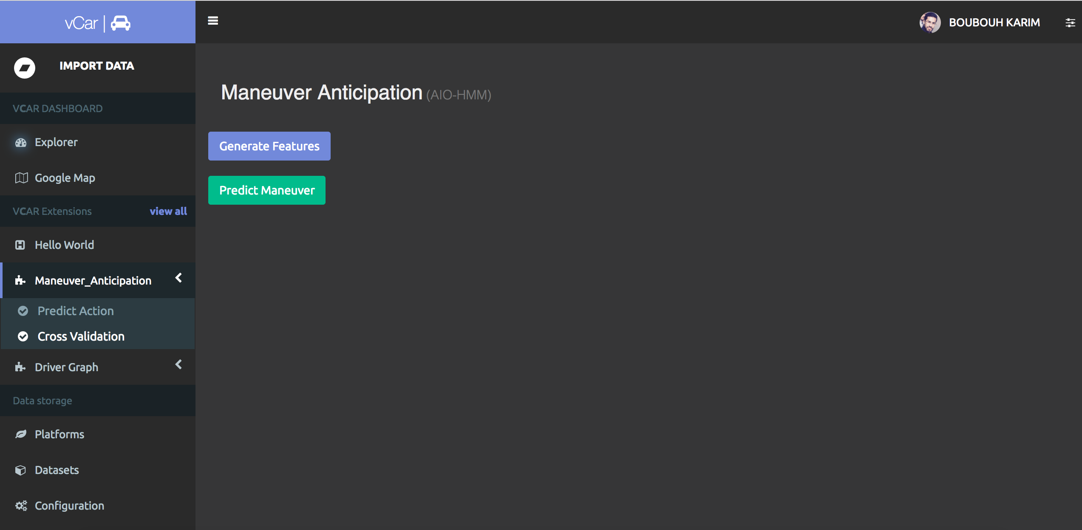Our plugin is integrated in vCar to predict maneuver based on the data imported by user (previous paragraph). As shown in (Fig 7) we have two types of prediction user can predict the maneuver by uploading his file (. mat) included in local dataset or by our dataset he can make a 5 cross validation. If user choose to predict maneuver of one file he first should upload his file from the local dataset (Fig 8) and then click on Predict Action (Fig 9). Once the algorithm finishes, the predicted maneuver appears on the window (Fig 10).

1. 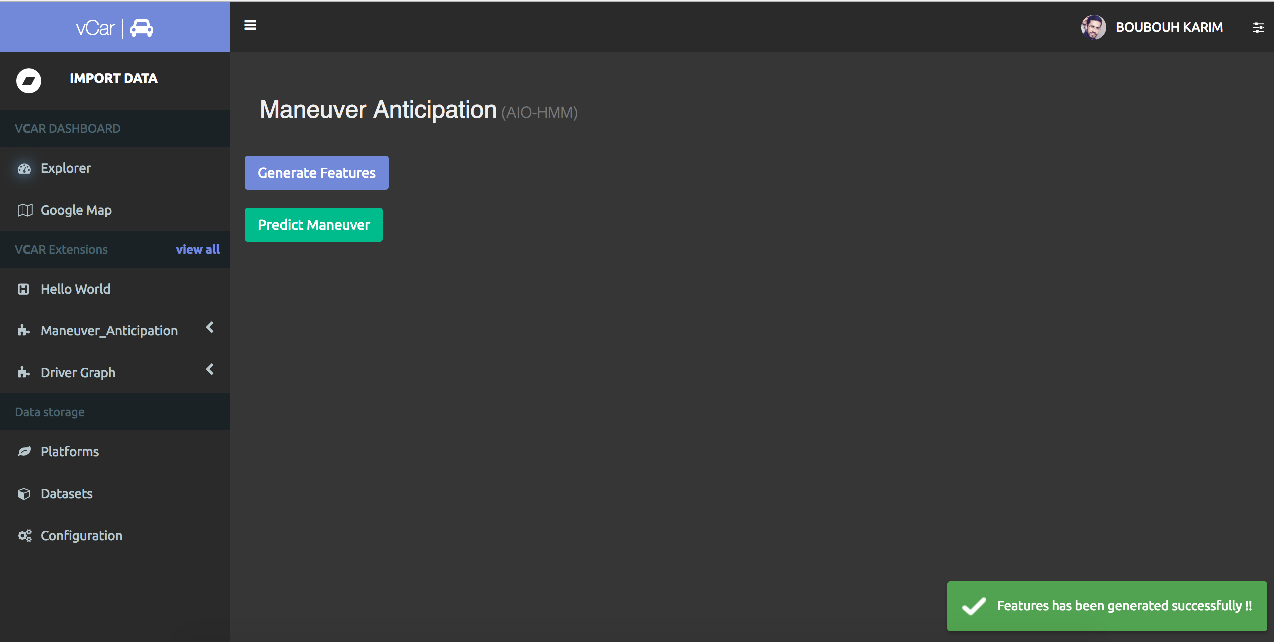Generate Features
2. Notification appears when the features are generated successfully

If user choose to make a cross validation of the local dataset he should before start predicting user should generate features first by clicking on Generate Features (Fig 11), a popup notification appears when the procedure is finished (Fig 12). Once features are generated user can start predicting driving maneuvers via Autoregressive input-output hidden markov model using the algorithm mentioned in section 3. Once prediction is finished a new html window appears representing plots (Fig 13) that measures the accuracy as the prediction threshold and time-to-maneuver varies.

1. 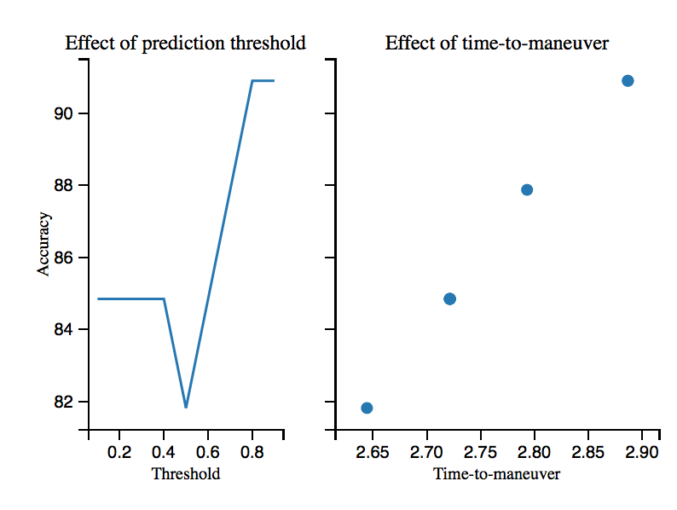Effect of threshold and time to maneuver on accuracy

|  |  |  |  |  |  |  |  |
| --- | --- | --- | --- | --- | --- | --- | --- |
| **Thresh** | **Turns** | | | | | | |
| Rturn | | Lturn | | End_action | | Mean time-to-maneuver |
| pr | re | pr | re | pr | re |
| 0.5 | 61.5% | 88.9% | 100% | 66.7% | 100% | 91.7% | 2.64 |
| 0.7 | 72.7% | 88.9% | 90.9% | 83.3% | 100% | 91.7% | 2.79 |
| 0.8 | 75% | 100% | 100% | 83.3% | 100% | 91.7% | 2.88 |

Table 1: showing precision, recall and mean time-to-maneuver computed from 5-fold cross-validation.

1. **Environment**

The platform is well tested on the Mac OS X 10.12 system, Using Python 2.7, and Flask. Flask is a micro web framework written in Python and based on the Werkzeug toolkit and Jinja2 template engine. The latest stable version of Flask is 0.12 as of December 2016. Applications that use the Flask framework include Pinterest, LinkedIn, and the community web page for Flask itself. For managing instant events to clients the platform uses "Redis”. Redis is an in-memory database open-source software project implementing a networked, in-memory key-value store with optional durability. Redis supports different kinds of abstract data structures, such as strings, lists, maps, sets, sorted sets, hyperloglogs, bitmaps and spatial indexes. The project is mainly developed by Salvatore Sanfilippo and is currently sponsored by Redis Labs. For results visualization we used mpld3. The mpld3 brings together Matplotlib, the popular Python-based graphing library, and D3js, the popular JavaScript library for creating interactive data visualizations for the web. The result is a simple API for exporting your matplotlib graphics to HTML code which can be used within the browser, within standard web pages, blogs, or tools such as the IPython notebook.

1. **Data**

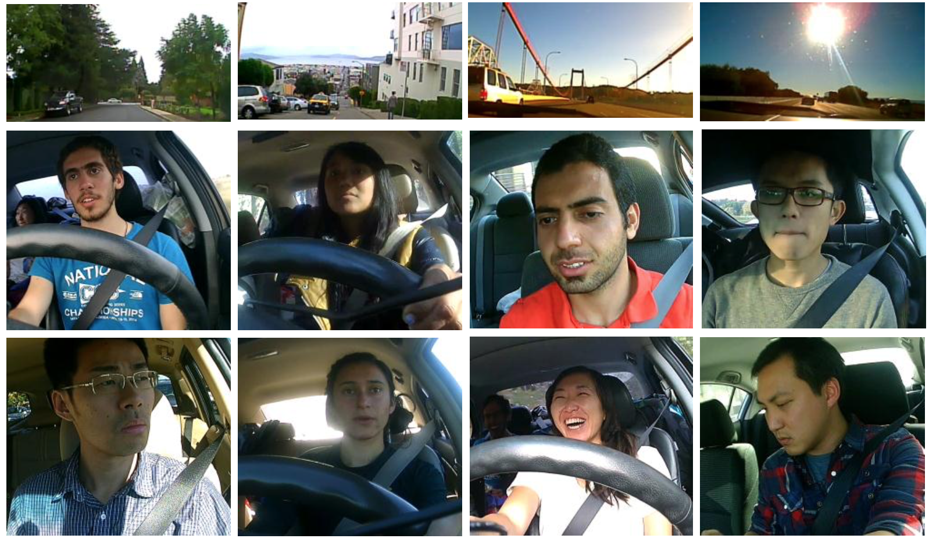

1. Data set is diverse in drivers and landscape.

We used Brain4cars dataset for our evaluations. The dataset consists of natural driving videos with both inside and outside views of the car, its speed, and the GPS coordinates. The outside car video captures the view of the road ahead. This driving data set collected under fully natural settings without any intervention. It consists of 1180 miles of freeway and city driving and encloses 21,000 square miles across two states. This data set collected from 10 drivers over a period of two months.

The complete data set has a total of 2 million video frames and includes diverse landscapes. (Fig 14) shows a few samples from the data set. We worked on a dataset that contains driving videos with a total of 594 events containing 247 lane changes, 113 turns, and 234 randomly sampled instances of driving straight. Each lane change or turn annotation marks the start time of the maneuver, i.e., before the car touches the lane or yaws, respectively. For all annotated events, they also annotated the lane information, i.e., the number of lanes on the road and the current lane of the car.

1. **Use case**

We extensively evaluated on 594 events our used approach to anticipate driving maneuvers few seconds before they occur. We evaluate anticipation algorithm on the maneuvers not seen during training with the following prediction settings: Turns: algorithm only anticipate turns, i.e. M = {left turn, right turn, driving straight}.

1. **Results**

During this process of anticipation and prediction, the algorithm makes (i) true predictions (tp): when it predicts the correct maneuver; (ii) false predictions (fp): when it predicts a maneuver but the driver performs a different maneuver; (iii) false positive predictions (fpp): when it predicts a maneuver but the driver does not perform any maneuver (i.e. driving straight); and (iv) missed predictions (mp): when it predicts driving straight but the driver performs a maneuver.

We evaluate the algorithm using precision and recall scores:

$$Pr=\frac{tp}{tp+fp+fpp}$$

$$Re= \frac{tp}{tp+fp+mp}$$

The precision measures the fraction of the predicted maneuvers that are correct and recall measures the fraction of the maneuvers that are correctly predicted. For true predictions (tp) we also compute the average time-to-maneuver, where time-to-maneuver is the interval between the time of algorithm’s prediction and the start of the maneuver. Precision, recall and time-to-maneuver computed from 5-fold cross-validation.

The algorithm makes a prediction only when its confidence is above the prediction threshold, as shown in Table 1 showing precision, recall and mean time-to-maneuver changing by changing threshold as we can see from 0.6 to 0.8 time to maneuver has increased by 0.24s witch make a big difference in prediction.

In (Table 1) we measure the accuracy as the prediction threshold and time-to-maneuver varies. Our results show that prediction accuracy improves with an increasing threshold value. By increasing time-to-maneuver with 0.24s accuracy has increased from 81.81% to 90.90%.

# Conclusion And Future Work

This paper introduces a hidden variable probabilistic model capable of making early predictions about driving maneuvers.

Many researchers have studied this particular case. Even though a significant number of publications can be found in this field, fundamental problems still need to be solved. Few researches use methods depending on inputs from devices other than visual sensors. But most of the algorithms are depending on visual information. There are many drawbacks regarding these methods. For example, most of the algorithms are time-costing and are not fit for real-time applications. In our work we used an AIO-HMM to jointly model the driver’s intention and the driving context from both inside and outside of the car in order to predict turns maneuvers several seconds before they occur.

Our future plan is to train our algorithm for all maneuvers (line changes), try to improve time-to-maneuver, improve the representation of results, and add more features like eye gaze. The driver’s eye-gaze is also a useful feature to improve performance.

# Acknowledgement

I would like to express my special thanks of gratitude to my professor Ismail Berrada who gave me the golden opportunity to do this wonderful project on the topic driving maneuver anticipation, which also helped me in doing a lot of research to get to know this and I came to know about so many new things.

My sincere thanks also goes to all of our professors of LIMS laboratory who gave access to the laboratory and research facilities. Without their precious support it would not be possible to conduct this research.

Last but not the least, I would like to thank my family: my parents and to my brother and sister for supporting me spiritually throughout this work and my my life in general. I would Like too to thank my friends who helped me a lot in finalizing this project within the limited time frame.

# References

1. “Human Behavior Prediction using Facial Expression Analysis” Tribhuvan University, International Conference on Computing, Communication and Automation (ICCCA2016)
2. “Face Recognition: A Literature Survey”, University of Maryland, ACM Computing Surveys, Vol. 35, No. 4, December 2003, pp. 399–458.
3. “A Study On Driver Fatigue Notification Systems”, Faculty of Engineering Technology, Universiti Malaysia Pahang, January 2016
4. L. Rabiner, “A tutorial on Hidden Markov Models and selected applica- tions in speech recognition,” Proc. IEEE, vol. 77, no. 2, pp. 257–286, Feb. 1989.
5. C. D. Manning and H. Schu ̈tze, Foundations of Statistical Natural Lan- guage Processing. Cambridge, MA, USA: MIT Press, 1999.
6. A. Krogh, M. Brown, I. S. Mian, K. Sjlander, and D. Haussler, “Hid- den Markov models in computational biology: Applications to protein modeling,” J. Molecul. Biol., vol. 235, pp. 1501–1531, 1994
7. D. Coast, R. Stern, G. Cano, and S. Briller, “An approach to cardiac arrhythmia analysis using hidden Markov models,” IEEE Trans. Biomed. Eng., vol. 37, no. 9, pp. 826–836, Sep. 1990.
8. R.Andreao,B.Dorizzi,andJ.Boudy,“ECGsignalanalysisthroughhid- den Markov models,” IEEE Trans. Biomed. Eng., vol. 53, no. 8, pp. 1541– 1549, Aug. 2006.
9. M. E. Tipping. Sparse bayesian learning and the relevance vector machine. JMLR, 1, 2001.
10. [10] Y. Ephraim, D. Malah, and B.-H. Juang, “On the application of hidden Markov models for enhancing noisy speech,” IEEE Trans. Acoust., Speech Signal Process., vol. 37, no. 12, pp. 1846–1856, Dec. 1989.
11. P.Woodland,“HiddenMarkovmodelsusingvectorlinearpredictionand discriminative output distributions,” in Proc. IEEE Int. Conf. Acoust., Speech, Signal Process., 1992, vol. 1, pp. 509–512.
12. Online Sequential Prediction via Incremental Parsing: The Active LeZi Algorithm , 1541-1672/07/$25.00 © 2007, IEEE Computer Society
13. K. M. Kitani, B. D. Ziebart, J. A. Bagnell, and M. Hebert. Activity forecasting. In Proceedings of the European Conference on Computer Vision, 2012.
14. N. Krishnan and D. J. Cook. Activity recognition on streaming sensor data. Pervasive and Mobile Computing, 10:138–154, 2014.
15. P. Viola and M. J. Jones. Robust real-time face detection. IJCV, 57(2), 2004.
16. J.ShiandC.Tomasi.Goodfeaturestotrack.InCVPR,1994.
17. D.Cristinacce and T. Cootes Feature Detection and Tracking with Constrained Local Model
18. Driver Action Prediction Using Deep (Bidirectional) Recurrent Neural Network